**MOSFETs as a Switch**

The N-channel, Enhancement-mode MOSFET (e-MOSFET) operates using a positive input voltage and has an extremely high input resistance (almost infinite) making it possible to interface with nearly any logic gate or driver capable of producing a positive output.

Due to this very high input (Gate) resistance we can safely parallel together many different MOSFETS until we achieve the current handling capacity that we required.

While connecting together various MOSFETS in parallel may enable us to switch high currents or high voltage loads, doing so becomes expensive and impractical in both components and circuit board space. To overcome this problem **Power Field Effect Transistors** or **Power FET’s** where developed.

There are two main differences between field effect transistors, depletion-mode only for JFET’s and both enhancement-mode and depletion-mode for MOSFETs. Here we will look at using the Enhancement-mode MOSFET as a Switchas these transistors require a positive gate voltage to turn “ON” and a zero voltage to turn “OFF” making them easily understood as switches and also easy to interface with logic gates.

The operation of the enhancement-mode MOSFET, or e-MOSFET, can best be described using its I-V characteristics curves shown below. When the input voltage, ( VIN ) to the gate of the transistor is zero, the MOSFET conducts virtually no current and the output voltage ( VOUT ) is equal to the supply voltage VDD. So the MOSFET is “OFF” operating within its “cut-off” region.

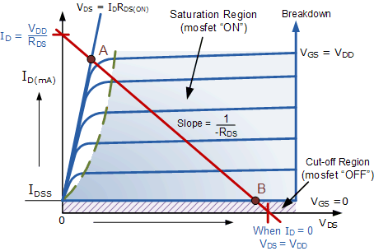

In this circuit arrangement an Enhancement-mode N-channel MOSFET is being used to switch a simple lamp “ON” and “OFF” (could also be an LED).

The gate input voltage VGS is taken to an appropriate positive voltage level to turn the device and therefore the lamp load either “ON”, ( VGS = +ve ) or at a zero voltage level that turns the device “OFF”, ( VGS = 0V ).

If the resistive load of the lamp was to be replaced by an inductive load such as a coil, solenoid or relay a “flywheel diode” would be required in parallel with the load to protect the MOSFET from any self generated back-emf.

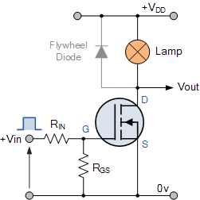

Above shows a very simple circuit for switching a resistive load such as a lamp or LED. But when using power MOSFETs to switch either inductive or capacitive loads some form of protection is required to prevent the MOSFET device from becoming damaged. Driving an inductive load has the opposite effect from driving a capacitive load.

For example, a capacitor without an electrical charge is a short circuit, resulting in a high “inrush” of current and when we remove the voltage from an inductive load we have a large reverse voltage build up as the magnetic field collapses, resulting in an induced back-emf in the windings of the inductor.

Then we can summarise the switching characteristics of both the N-channel and P-channel type MOSFET within the following table.

|  |  |  |  |
| --- | --- | --- | --- |
| MOSFET Type | VGS (+ve) | VGS (0V) | VGS (-ve) |
| N-channel Enhancement | ON | OFF | OFF |
| N-channel Depletion | ON | ON | OFF |
| P-channel Enhancement | OFF | OFF | ON |
| P-channel Depletion | OFF | ON | ON |

Note that unlike the N-channel MOSFET whose gate terminal must be made more positive (attracting electrons) than the source to allow current to flow through the channel, the conduction through the P-channel MOSFET is due to the flow of holes. That is the gate terminal of a P-channel MOSFET must be made more negative than the source and will only stop conducting (cut-off) until the gate is more positive than the source.

So for the enhancement type power MOSFET to operate as an analogue switching device, it needs to be switched between its “Cut-off Region” where: VGS = 0V (or VGS = -ve) and its “Saturation Region” where: VGS(on) = +ve. The power dissipated in the MOSFET ( PD ) depends upon the current flowing through the channel ID at saturation and also the “ON-resistance” of the channel given as RDS(on).